8. PROTOTYPING

**8.1 Mock-ups**

To create quick, simple designs of the website we used an online tool called MockFlow.

**8.1.1 Log-In Page**

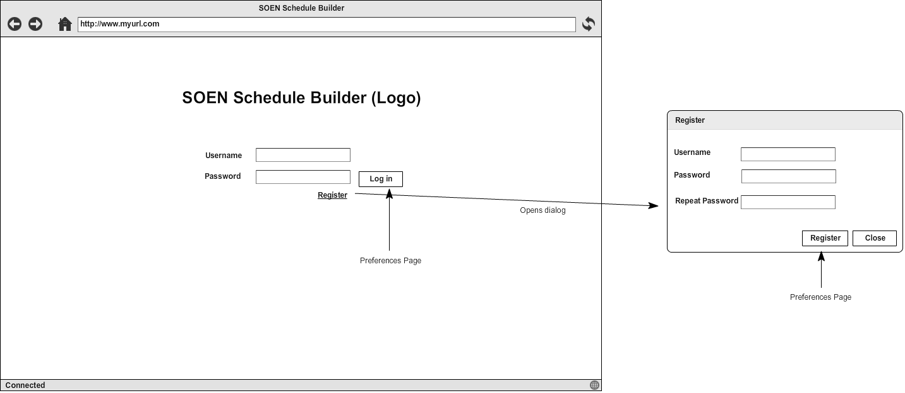

**8.1.2 Preference Page**

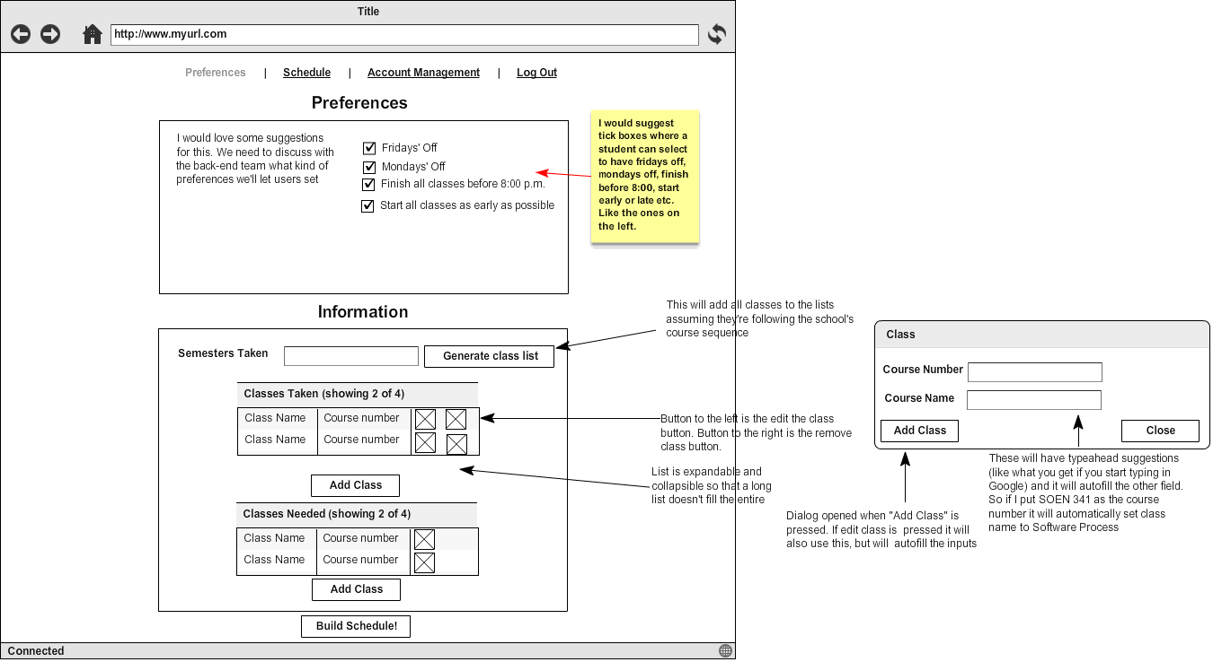

**8.1.3 Schedule Page**

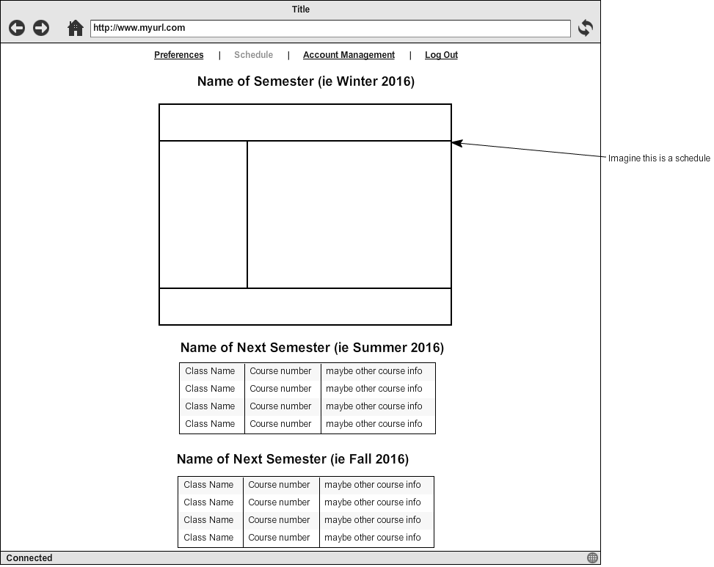

**8.1.4 Account Management Page**

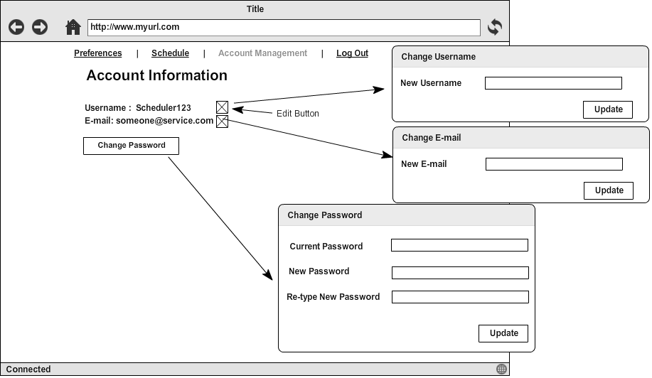

**8.2 Prototype**

To prove that the different frameworks work together, we decided to just have registration and log-in functionality, with the basic structure of the UI for the first two pages. This allows for some basic communication between the front and back end.

**8.2.1 Log-In Page**

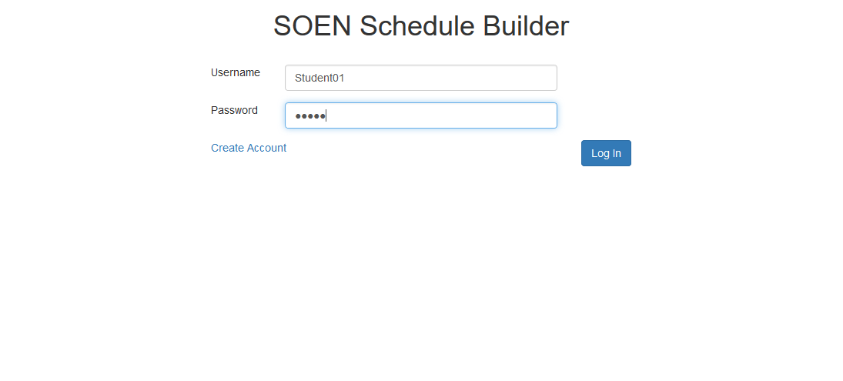

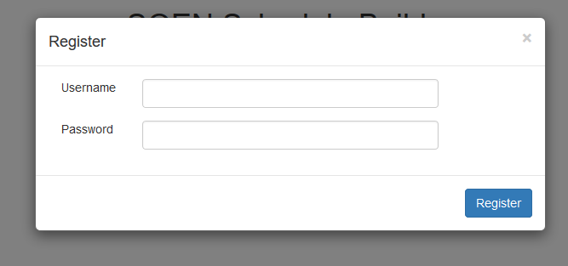

The registration dialog on the log-in page

**8.2.2 Preference Page**

